

Artificial Intelligence (AI) – Cover Sheet
ASSIGNMENT

Instruction:
• Marks will be awarded for good presentation and thoroughness in your approach.
• Referencing Code: If you use some code, or ideas for code, which are taken or adapted from another source (book, magazine, internet, discussion forum, etc), then this must be cited and referenced using the Harvard Name convention within your source code. Failure to reference code properly is considered as plagiarism.
• Complete this cover sheet and attach it to your project.
- This project is to be attempted by a group of 3 students.

Student declaration:
I declare that: | - We understand what is meant by plagiarism  - The implication of plagiarism have been explained to us by our lecturer  - This project is all our work and we have acknowledged any use of the published or unpublished works of other people.
Group Leader’s Signature:  |  | Date: November 28, 2023.

Project Title: |  | Congas Drum | Intake:APU1F2303CS(IS)
Role | Name |  |  | Signature
Team Leader | YEHIA RASHEED YEHIA AL HADDAD |  |  | 
Knowledge  Engineer | MOHAMMADOMAR HASHEMI |  |  | 
Programmer | SULTAN FATEHI ALI HAKAMI |  |  | 

Table of content
Table of content 2
1. Problem Specifications 5
1.1 Abstract 5
1.2 Problem Statement 6
1.2.1 Problem Statement 1 6
1.2.2 Problem Statement 2 7
1.2.3 Problem Statement 3 9
2.1 Knowledge acquisition 10
2.1.1 Framework 10
3.0 Semantic Nets/Network 12
3.1. Literature Review On Chatterbots/Chatbots 12
3.1.1 Journal 1 - User Experiences of Social Support From Companion Chatbots in Everyday Contexts 13
3.1.2 Journal 2 - Design of Multimodal Chatbot for an Experiential Media System 14
3.1.3 Journal 3 - A Chatbot Solution for Self-Reading Energy Consumption via Chatting Applications 15
3.1.4 Journal 4 - Designing Intelligent Personalized Chatbot for Hotel Services 17
3.1.5 Journal 5 - Intelligent Chatbot Model to Enhance the Emotion Detection in social media using Bi-directional Recurrent Neural Network 18
3.1.6 Journal 6 - An AI-Based Medical Chatbot Model for Infectious Disease Prediction 18
3.1.7 Journal 7 - a Chatbot for News Dissemination during Crisis: Design, Implementation and Evaluation 19
3.1.8 Journal 8 - Chatbot for Young People’s Sexual and Reproductive Health in India (SnehAI): Instrumental Case Study 20
3.1.9 Journal 9 - a Chatbot Program for Follow-Up Management of Workers’ General Health Examinations in Korea: A Pilot Study 21
4.1 Special features 23
4.2 User Satisfaction survey 26
4.3 User Acceptance Testing Outcomes 28
5.0 Conclusion 33
6.0 References 34
7.0 Workload matrix 36

1. Problem Specifications

1.1 Abstract
Along the lines of the Sustainable Development Goals (SDGs) of Quality Education, Sustainable Cities and Communities, and Decent Work and Economic Growth, the CongaDrumBot is a unique chatbot powered by artificial intelligence that was developed to promote the cultural and pedagogical significance of conga drumming. This interactive website not only educates users about the history of conga drumming and the skills required to play it, but it also encourages cultural diversity and economic advancement by connecting them with local conga drum artisans and markets. The fact that users like the bot and are likely to use it again is evidence that it is successful in engaging users and improving their learning experience. User satisfaction polls reveal that users will use the bot again. Additional features that will be added to the chatbot in the future include enhanced personalization possibilities, broader multilingual support, and the assurance of content compliance and relevance within the context of privacy regulations. CongaDrumBot's function as a vehicle for education, cultural interaction, and economic development will be strengthened if these challenges are addressed. This will result in the expansion of the conga drum tradition while also contributing to the achievement of the Sustainable Development Goals (SDGs).
while adhering to the Sustainable Development Goals (SDGs) to improve education, cultural understanding, and economic viability.

1.2 Problem Statement
The Sustainable Development Goals (SDGs) cover a wide range of topics, including education, economic growth, cultural diversity, sustainable communities, responsible manufacturing, environmental protection, and international cooperation. Conga drums have a multifaceted role to play in the achievement of the SDGs, particularly in the areas of education, economic growth, cultural diversity, and sustainable communities. These goals can be strengthened and made further progress if they are included, along with the cultural value of conga drums, into a variety of programmes.

1.2.1 Problem Statement 1

Quality Education, Sustainable Development Goal 4, covers all educational advancements.

Figure 1.2.1: Quality Education, SDG 4
Conga drums in music education help reach Sustainable Development Goal 4, which seeks quality instruction. This integration promotes cultural variety, innovation, and inclusive education in a unique way. Conga drums help explain worldwide cultures, rhythmic patterns, and history.
Educational conga drums go beyond basic music instruction. The curriculum teaches students to Latin American and African cultures that inspired these musical instruments. Music in children's education promotes global citizenship and cultural empathy by exposing them to many cultures. In our increasingly interconnected globe, cultural barriers must be broken and diversity appreciated.
Students have cognitive challenges when learning conga drumming. Coordination, rhythm, and timing are essential for brain maturation and musical skill. Conga drumming improves memory, attention, and focus. Cognitive training that develops brain networks benefits young learners.
Conga drumming improves motor skills. Kids' hand-eye coordination and fine motor abilities improve with rhythmic hand movements. The development of motor skills in early education is vital to physical development.
Additionally, conga drumming is social. Students must work together and communicate well to develop collaboration and social skills. Students learn timing, active listening, and harmonisation by playing music together, which they can use in school and life.
The inclusion of conga drums in the curriculum requires inclusive education. Use of conga drums in music instruction can create an inclusive learning environment for students with different learning styles and skills. Some students who struggle in standard academic courses may use alternate methods of expression and learning. Inclusion is essential to creating an educational environment that gives all children a sense of worth and academic success.
The holistic use of conga drums in music instruction supports Sustainable Development Goals. 4. Skill development improves education, cultural awareness, inclusivity, and student well-being. This strategy develops students with outstanding intellectual talents, cultural sensitivity, inventive thinking, and strong social skills.

1.2.2 Problem Statement 2
Sustainable Development Goal 11 covers Sustainable Cities and Communities. The discussion also covers Conga Drums.
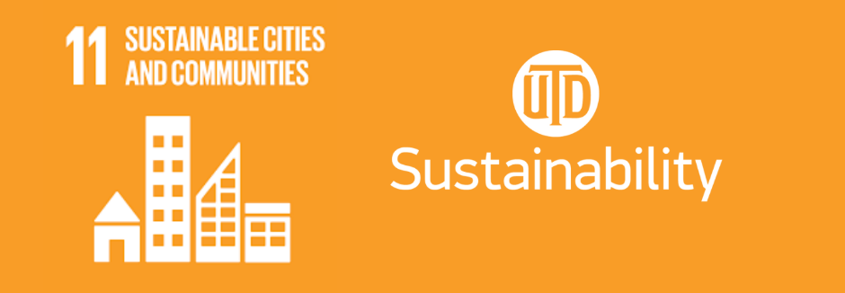
Figure 1.2.2: Sustainable Cities and Communities, SDG 11

Conga drums improve community culture and help achieve Sustainable Development Goal 11. This objective promotes inclusive, safe, resilient, and sustainable cities and settlements. Conga drums' resonant cadence entertains and expresses communal identity and solidarity, which are important in urban and rural settings.
Metropolitan life is fast-paced and chaotic, so people often feel detached and anonymous. However, conga drum performances at community events can unite neighbours. This platform brings people of various backgrounds together to share experiences and celebrate their humanity. This provides a sense of belonging and strengthens urban societies, creating inclusion and enabling them to survive urbanisation.
Conga drums help preserve and promote indigenous culture and traditions in rural areas. Public parks can foster communal pride and cooperation. Globalisation often threatens local cultures, making their preservation more important. Communities maintain their identity and culture by upholding these customs.
Conga drums in festivals and cultural events are very important for sustainable tourism. Tourism practises that preserve local customs and arts, including music, can benefit the community economically while preserving their cultural heritage. This style of tourism promotes a sustainable and egalitarian model in which visitors are active participants in a cultural exchange.
Conga drums are part of urban and neighbourhood culture and education. Experienced community members teach younger generations how to play and make these instruments. This practise preserves cultural traditions and fosters communal identity and connectedness.
Additionally, public locations that hold conga drum performances and courses are vibrant cultural hubs. Since they provide artistic expression, recreation, and relaxation, these locations improve community well-being.

1.2.3 Problem Statement 3
Sustainable Development Goal 8 promotes decent work and economic prosperity and includes many variables. In this environment, Conga drums may contribute to economic progress and cultural expression.

Figure 1.2.3: Decent Work and Economic Growth, SDG 8

The conga drum industry aligns with Sustainable Development Goal 8, which promotes long-term, comprehensive, and sustainable economic growth, abundant and productive employment, and fair work conditions for all. Conga drums are made by skilled artisans and contribute to a larger economic network of material suppliers, distributors, retailers, and music educators. Culturally significant locations produce conga drums for survival, often passed down through generations. This practise protects cultural resources and sustains local economies. Communities may retain their culture and grow economically by supporting these skilled craftsmen. This is vital in communities that need economic diversification and where traditional crafts can generate income.
Global commerce is also possible in the musical instrument sector, which includes conga drums. This could boost local and national economies. Exporting these instruments can boost trade earnings, the balance of payments, and nations' worldwide economies.
Conga drum retail and distribution networks create more jobs. From tiny music shops to multinational internet merchants, the distribution chain creates jobs and boosts the economy. These musical instruments are used as teaching tools by educators and tutors in music education, creating educational opportunities and jobs.
Through cultural tourism, conga drums boost the economy. Regions known for making these musical instruments might attract travellers interested in music and culture, boosting economic growth and tourism employment.
practises. It helps individuals and communities economically and supports sustainable development. This instance shows how traditional crafts and cultural commodities can be used to achieve economic, social, and environmental sustainability.

2.1 Knowledge acquisition
Knowledge acquisition refers to the knowledge that a firm can try to obtain from external sources. External knowledge sources are important and one should therefore take a holistic view of the value chain. Sources include suppliers, competitors, partners/alliances, customers, and external experts. Communities of practice can extend well outside the firm. (Hajric, 2018)

2.1.1 Framework
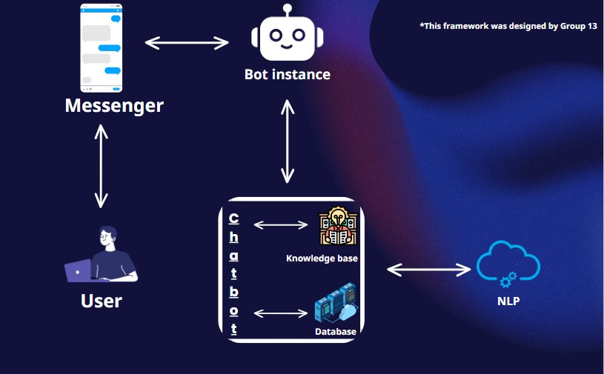
Figure 2.1.1: framework Design

User: The person communicating with the chatbot. A messaging platform is used by the user to send and receive messages.
Messenger: This is the communication platform between the user and the bot. Messaging apps like WhatsApp, Facebook Messenger, and web-based chat interfaces are common examples.
Bot Instance: This is the actual chatbot. It is the software entity that processes the user's incoming messages, decides on the best response, and sends that response back to the user via the messenger.
Context: The central section of the framework where the majority of the processing occurs. It is subdivided as follows:

The knowledge base holds the information from which the chatbot may answer inquiries or offer information. It contains pre-programmed responses, FAQs, and other pertinent information.
The database is where the chatbot gets dynamic data that changes over time. It may contain user profiles, transaction information, or any other data that must be kept and retrieved.
Natural Language Processing (NLP): This cloud illustrates the chatbot's AI capabilities, which include comprehending human language, recognising user intents, and providing coherent and contextually relevant responses.
The arrows represent the flow of information between the various components. The user uses the messenger to send a message to the bot. The bot instance then processes the message using its natural language processing capabilities, accesses the knowledge base and database as needed, and responds to the user via the messenger.
In essence, the architecture illustrates how the bot processes a user's question by interpreting the language, accessing the database and knowledge base for information, and producing a meaningful response. The general design suggests a closed-loop system in which the bot learns and evolves as it interacts with the user and the information sources to which it has access.

3.0 Semantic Nets/Network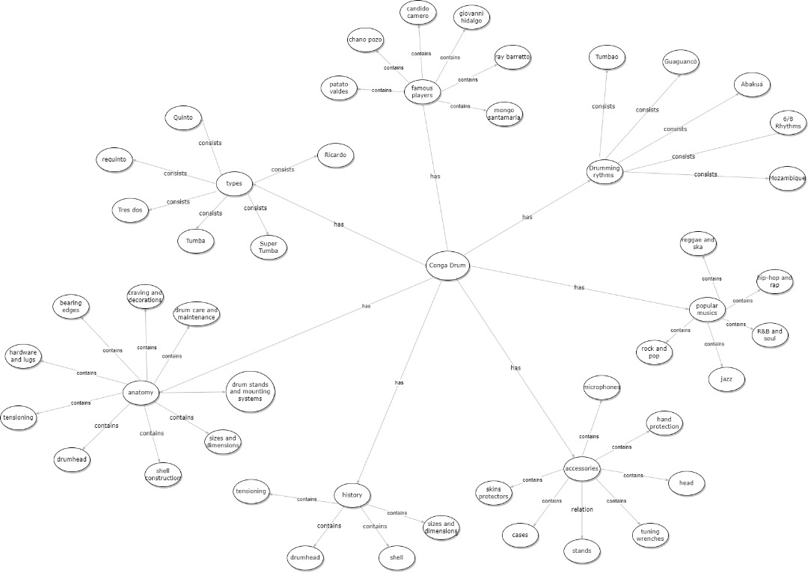
Figure 3.0: Semantic Nets/Network

3.1. Literature Review On Chatterbots/Chatbots
The rapid rise of chatbots, or conversational agents, has brought about significant developments in the realm of human-computer interaction. These AI-powered voice and text chat apps are utilized in many different sectors, such as customer service and healthcare. This study of the literature provides an overview of the history, technology, applications, challenges, and most recent advancements in the field of chatbots. It attempts to outline the current state of the art in chatbot development, look at how they affect communication between humans and machines, and make suggestions for further advancements in this quickly developing field. To aid in understanding the concepts covered, the following introduction offers well-known chatbot implementations from a variety of industries:

3.1.1 Journal 1 - User Experiences of Social Support From Companion Chatbots in Everyday Contexts
This study looks into the potential of artificial agents, specifically chatbots like Replika, to provide persons with everyday social support. While previous research has mostly focused on social support interventions during emergencies or health-related situations, this study investigates the role of artificial agents in offering assistance in everyday scenarios. To acquire information, two studies were conducted:
The first study examined 1,854 publicly available user reviews of Replika, a popular companion chatbot.
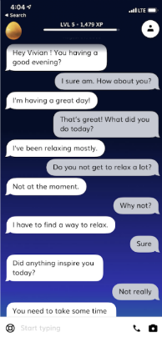
Figure 3.1.1: Social Support Chatbot

In Study 2, 66 Replika users provided extensive open-ended responses regarding their experiences.
According to the findings, Replika provides several types of everyday social support, such as companionship, creating a nonjudgmental space for discussions, boosting positive emotions through nurturing messages, and providing helpful information and advice when traditional informational support is unavailable. However, tangible help is not one of their strong suits.
These findings imply that artificial agents have the ability to give a wide range of ordinary social support, including companionship, emotional support, informational support, and evaluation support. More research is needed to determine which persons may benefit the most from this assistance and under what conditions. Furthermore, artificial agent assistance could play a part in resolving global health challenges and emergencies at an early stage in everyday scenarios.

3.1.2 Journal 2 - Design of Multimodal Chatbot for an Experiential Media System
This paper describes the development of a multimodal chatbot for use in interactive theatre performances. The chatbot has a sophisticated architecture that combines vision and natural language processing capabilities. It is physically manifested as a non-anthropomorphic moveable LED array on a stage. The system is designed to interact with several users at the same time, allowing up to five people at a time. The chatbot's capabilities include a variety of tasks, such as:
Face Detection and Emotion Classification: The system can recognise faces and classify emotions, allowing it to respond to user expressions and reactions accordingly.
Crowd Movement Tracking: The chatbot tracks the movement of the crowd in real-time using mobile phones, changing its responses and interactions accordingly.
Real-Time Conversation: The chatbot converses with users in real-time, guiding them through a nonlinear tale and interactive activities.
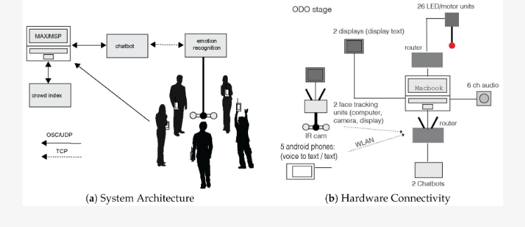
Figure 3.1.2: Multimodal Chatbot

The resulting prototype, dubbed ODO, is a physical manifestation of a distributed multimedia system. ODO successfully addresses a number of technical obstacles, giving users with a unique and immersive experience through novel ways of interaction.
This revolutionary approach to chatbot creation demonstrates how chatbots can enhance interactive theatre performances by increasing audience involvement and providing novel storytelling experiences.

3.1.3 Journal 3 - A Chatbot Solution for Self-Reading Energy Consumption via Chatting Applications
‌The concept of self-reading energy consumption has arisen as a potential solution for power companies in response to the financial challenges and sanitary requirements brought by the COVID-19 epidemic. This method involves users reading and reporting their own energy consumption, which eliminates the need for physical inspections. This paper describes an innovative technique for self-reading energy consumption that is assisted by chatbots within messaging apps. This solution is being worked on as part of a research and development (R&D) initiative.
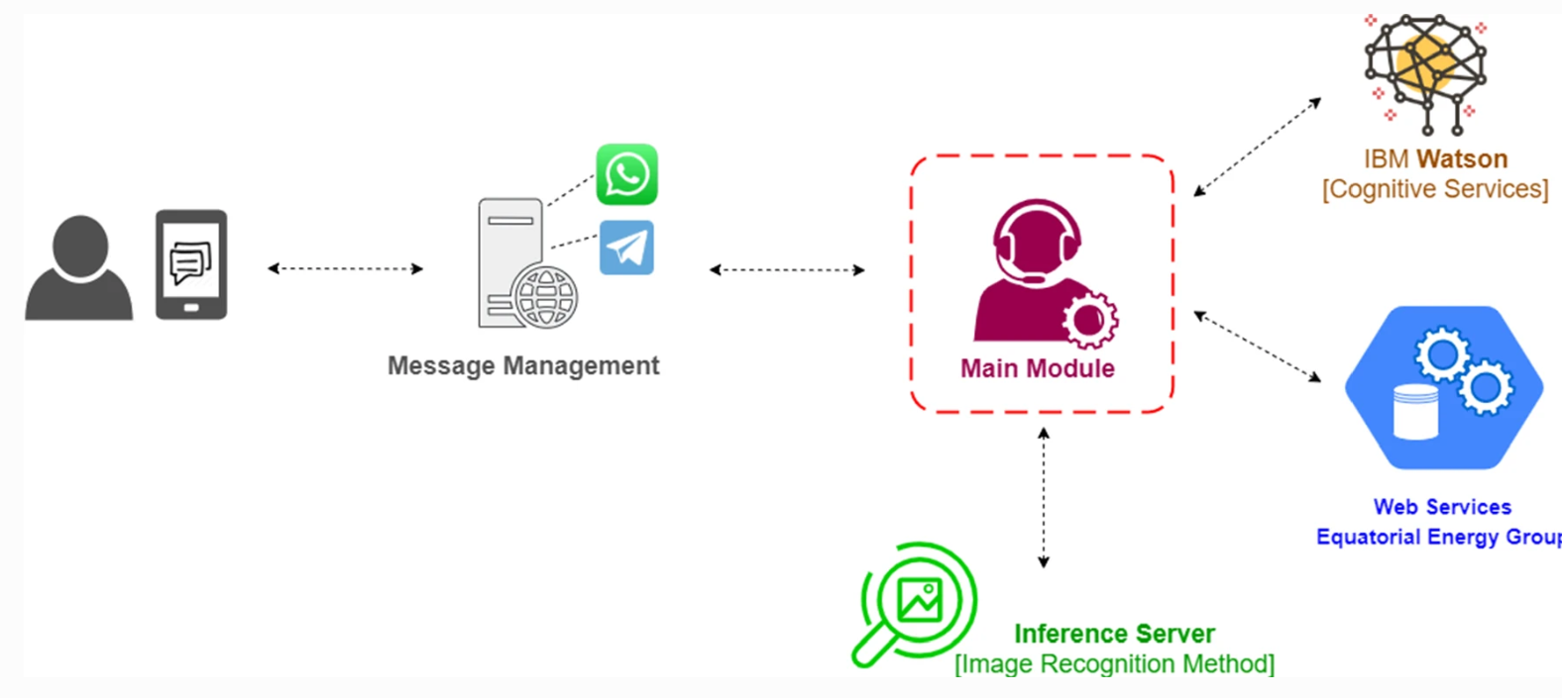
Figure 3.1.3: Self-Reading Chatbot

Solution's Key Components:
Image Processing: For validation reasons, the system includes image processing techniques to automatically scan energy consumption statistics and recognise the identifying code of a metre.
Cognitive Services: IBM Watson platform cognitive services are used to comprehend user intentions and promote dialogues with consumers, enabling efficient and user-friendly interactions.
Dataset Validation: The suggested self-reading approach is validated using a dataset that includes instances of both analogue and digital metres used by the Equatorial Energy group.
Preliminary Findings:
Accuracy in recognising complete reading sequences and identifying codes was 77.20% for digital metres and 84.30% for analogical metres, respectively.
The approach obtains an outstanding accuracy rate of 97% per digit by combining both metre kinds.
Furthermore, the suggested method was tested using the public UFPR-AMR dataset, providing results comparable to the state of the art in self-reading energy usage.
This creative solution not only addresses the pandemic's issues, but also highlights the potential for chatbots and image processing to expedite energy usage reporting, benefiting both consumers and electricity companies.

3.1.4 Journal 4 - Designing Intelligent Personalized Chatbot for Hotel Services
‌Globally, substantial progress has been made in the development of chatbots for customer support and sales. However, research on the development of chatbot-hotel solutions in Indonesia has been sparse. This article focuses on the potential benefits of chatbot-hotel systems for both hotels and smartphone users, emphasising the advantages of ease, cost savings, personalised marketing, and data collection.

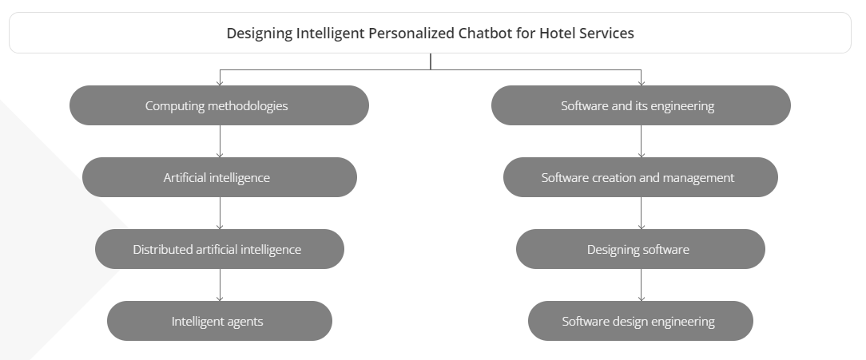
Figure 3.1.4: Chatbot for Hotel Services

The Chatbot-Hotel System's Key Features:
Accessibility: Using chatbots, consumers with smartphones can connect with a hotel at any time and from any location, gaining access to personalised services suited to their unique needs.
Customers can inquire about room availability, pricing, make reservations, and interact with a virtual front office that gives real-time and contextually relevant information about hotel services.
The chatbot-hotel is built with AIML (Artificial Intelligence Markup Language) and Google Flutter, a cross-platform mobile app development framework chosen for its simplicity and versatility.
The outcome of this endeavour is a prototype chatbot-hotel intended for mobile platforms, with a specific focus on Indonesian users. This chatbot covers a wide range of hotel services and excels at providing personalised services to consumers even before they visit. It is a useful tool for satisfying client needs and advertising hotel amenities, such as upselling chances.
This novel chatbot-hotel system not only improves client experiences but also has the potential to increase sales, save operational costs, and collect vital data for marketing purposes in the Indonesian hotel industry.

3.1.5 Journal 5 - Intelligent Chatbot Model to Enhance the Emotion Detection in social media using Bi-directional Recurrent Neural Network
A chatbot is similar to a digital assistant in that it can be pre-trained or learn on its own. It may be trained to interpret user questions and react in the user's native language throughout a conversation. Because it may use natural language processing, chatbots can actively assist humans in participating in digital conversations. The existing Chatbot improves conversation but does not provide information when it is required. And they occasionally stray from the topic of conversation, which is a huge disadvantage. Using Bi-directional Recurrent Neural Network and Tensor Flow Library features, the suggested bot can detect users' emotional states and make suggestions. Because of the popularity of chat bots, our technology can be utilised for a wide range of applications. These discussions
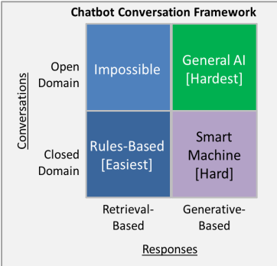
Figure 3.1.5: Emotion Detection Chatbot

3.1.6 Journal 6 - An AI-Based Medical Chatbot Model for Infectious Disease Prediction
How can we use chatbots to promote the medical sector and cure infectious diseases? We can raise awareness among users and provide them with appropriate medical remedies to prevent sickness. To increase human interaction in databases in 2021, we developed a preliminary training model and a study report. We characterise the human behaviours and characteristics of the chatbot using natural language processing. We propose an AI Chatbot interaction and prediction model based on a deep feedforward multilayer perceptron in this paper. Our research identified a knowledge gap in theoretical and practical criteria for developing AI chatbots for lifestyle improvement programmes. This report also includes a quick comparison of our proposed model in terms of time complexity and testing accuracy. Our work has a minimum loss of 0.1232 and a maximum accuracy of 94.32%. This study explains the functions and potential applications of medical chatbots and investigates the associated issues created by the usage of these developing technologies during such health crises, which are mostly caused by pandemics. We believe that our findings will assist researchers in gaining a better knowledge of the layout and applications of these new technologies, which will be essential for continual progress in medical chatbot functionality and valuable in preventing COVID-19.
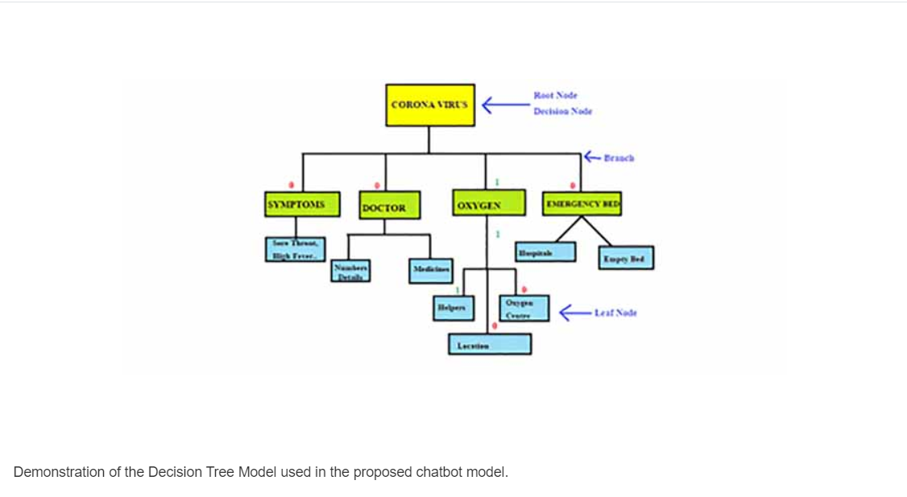
Figure 3.1.6: Medical Chatbot for infectious Disease prediction

3.1.7 Journal 7 - a Chatbot for News Dissemination during Crisis: Design, Implementation and Evaluation
Chatbots in news media platforms is relatively new, it provides several benefits to journalists and media professionals while also facilitating consumers' interaction with meaningful and timely information. The 2020 COVID-19 pandemic is used as a case study to demonstrate the usefulness of a news chatbot in a crisis situation. The primary goals of the research are to design and implement a chatbot in a news media platform with a two-fold evaluation goal: first, the technical effort of creating a functional and robust news chatbot in a crisis situation from the AI perspective and interoperability with other platforms, which constitutes the approach's novelty; and second, users' perceptions of the appropriation of this news chatbot as an alternative means of accessing information. The proposed chatbot was evaluated for its ability to effectively satisfy the social responsibility duty of crisis reporting, delivering timely and accurate information about the COVID-19 epidemic to a large audience. In this view, this study demonstrates the benefits of incorporating chatbots in news platforms during a crisis, when the audience's demand for speedy and reliable information skyrockets.
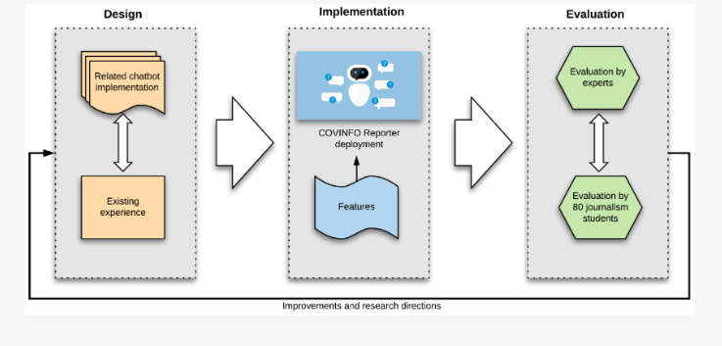
Figure 3.1.7: Design for Dissementation

3.1.8 Journal 8 - Chatbot for Young People’s Sexual and Reproductive Health in India (SnehAI): Instrumental Case Study
With a particular emphasis on sexual and reproductive health in India, this Chatbot investigates the novel application of chatbots powered by artificial intelligence for the purpose of health teaching and promotion. SnehAI is a pioneering Hinglish (Hindi + English) artificial intelligence chatbot that was developed by the Population Foundation of India. Its purpose is to facilitate conversations about taboo issues and provide credible information and resources in a manner that is both private and nonjudgmental. The primary objective of this Chatbot is to utilise the Gibson theory of affordances in order to conduct an analysis of SnehAI's capabilities and provide academic insights into the ways in which artificial intelligence chatbots can be utilised for the purpose of educating adolescents and young adults, promoting sexual and reproductive health, and advocating for the health rights of women and girls in India.
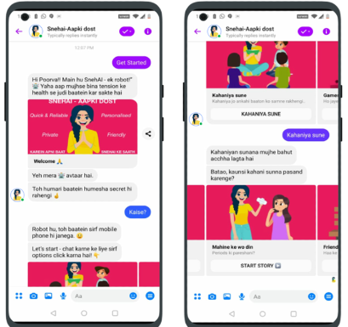
Figure 3.1.8: Sneh(AI) Chatbot

3.1.9 Journal 9 - a Chatbot Program for Follow-Up Management of Workers’ General Health Examinations in Korea: A Pilot Study
A chatbot, a digital healthcare tool, uses a mobile device to respond text or voice questions with appropriate information [9]. Due to the rise of smart gadgets, mobile (online) communication, and messenger apps, this technology is being employed in credit scoring [10] and marketing [11]. Chatbots are being used in digital healthcare. In Kangbuk Samsung Hospital, the chatbot “Kohby” delivers health checkup information and administrative functions like appointments and payments [12]. The chatbot also answers queries about symptoms and diseases and links patients with doctors via “HealthTap” [13] and “Babylon Healthcare” [14]. The chatbot also discusses cancer therapy [15,16], stress management [17], and mental health [18]. Chatbots also encourage behaviour changes like stopping smoking [19,20].
Because chatbots are tailored for mobile devices and can get the information they require without installing an app, users and service area are growing. However, no chatbot programme has been developed that clearly explains general health examination results and follow-up management approaches to the general people.
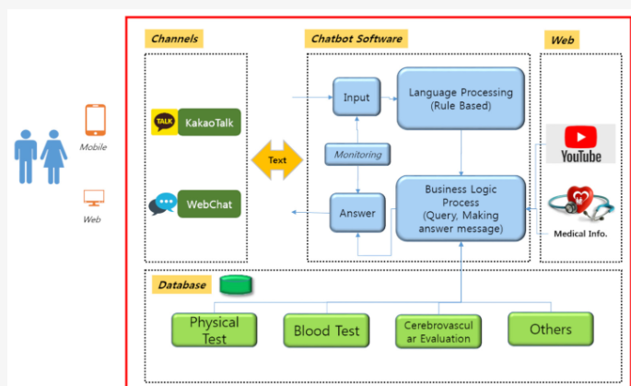
Figure 3.1.9: Follow-up program for workers
This pilot study is the first step in creating a WGHE follow-up chatbot. Using WGHE results, the study creates an early chatbot that provides health status information and management advice. This study also examines the chatbot program's efficacy for 2018 WGHE programme graduates and its applicability to nurses in the special agency of occupational health management who manage WGHE follow-up.

4.1 Special features

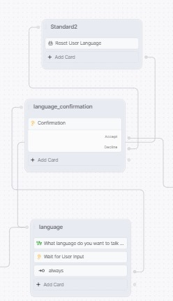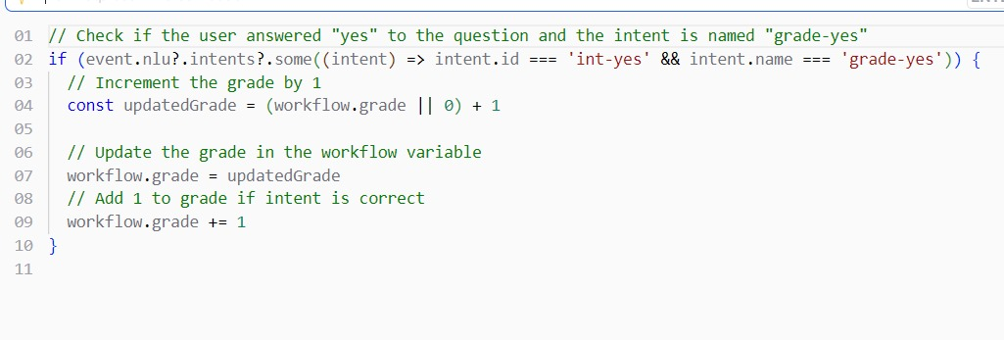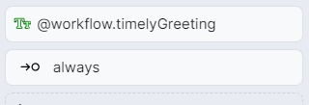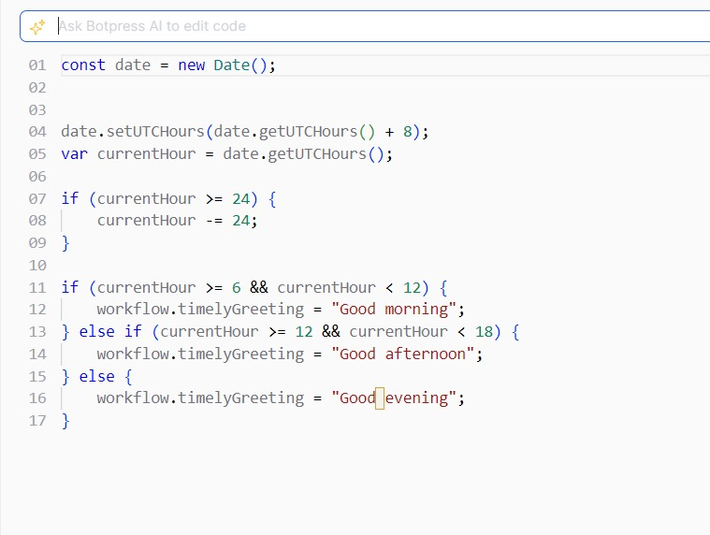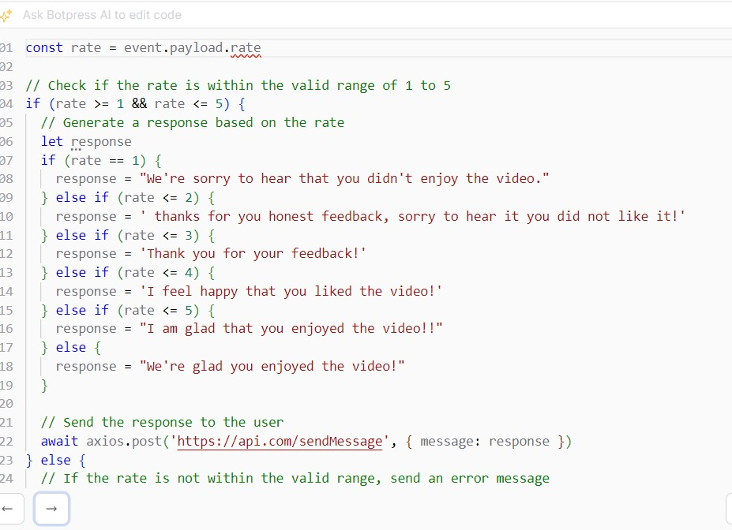
Figure 4.1.1 & 4.1.2 & 4.1.3 & 4.1.4 & 4.1.5: Special futures

4.2 User Satisfaction survey
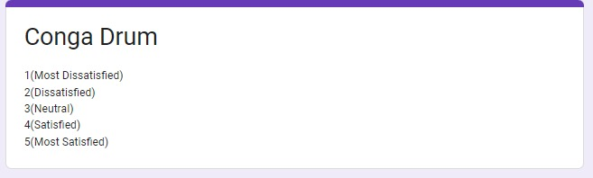
Figure 4.2.: User satisfaction survey
"Conga Drum." The survey uses a 5-point Likert scale for respondents to rate their level of satisfaction, where '1' represents 'Most Dissatisfied,' '2' represents 'Dissatisfied,' '3' is 'Neutral,' '4' is 'Satisfied,' and '5' indicates 'Most Satisfied.' Participants would select a number that corresponds to their personal level of satisfaction with the conga drum, allowing the surveyors to quantify and analyze the overall customer satisfaction.
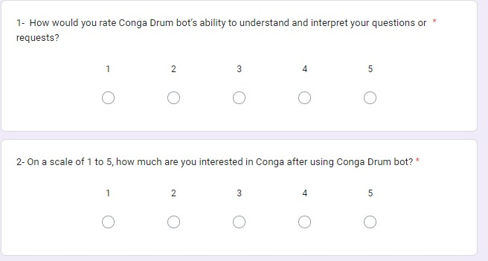
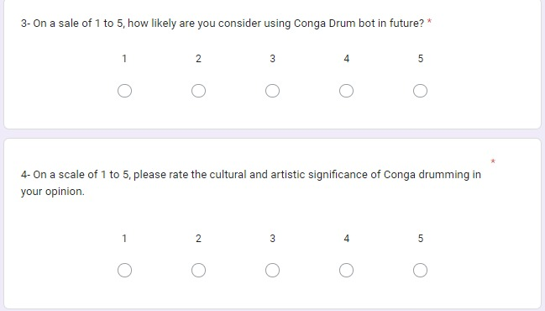

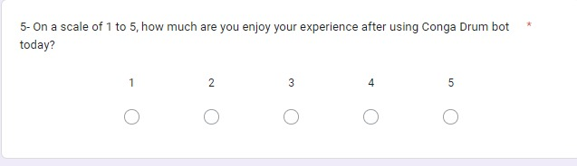
Figure 4.2.1 & Figure 4.2.2 & Figure 4.2.3: User Acceptance Testing Questionnaire

4.3 User Acceptance Testing Outcomes
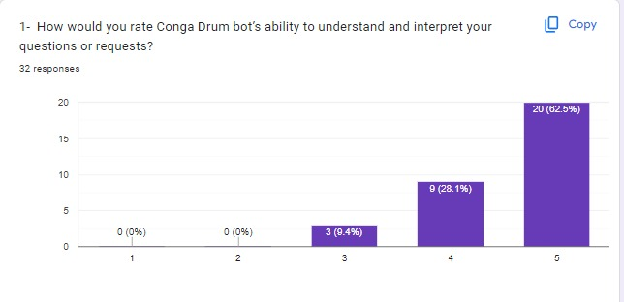
Figure 4.3.1: The First Online Questionnaire's Results
The graphic is a bar chart from a survey that rates the "Conga Drum bot's" ability to grasp and interpret inquiries or requests. There are a total of 32 answers. No responders selected the alternatives '1' (Most Dissatisfied) or '2' (Dissatisfied), indicating that there was no serious negative feedback. Three (9.4%) respondents selected '3' (Neutral), indicating an average or uncertain judgement on the bot's performance. The bot received a '4' (Satisfied) rating from eight respondents (28.1%), and a '5' (Most Satisfied) rating from the majority of 20 respondents (62.5%), indicating a strong good reception. This graphic representation provides for a quick assessment of user happiness, demonstrating that the majority of users are pleased with the bot's performance, with a sizable proportion considering it extremely satisfying.
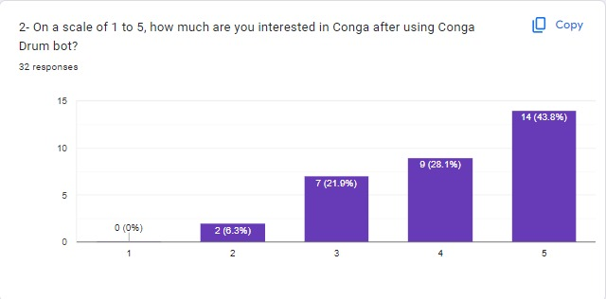
Figure 4.3.2: The Second Online Questionnaire's Results
The graphic depicts a bar chart displaying replies to a survey question on Conga interest after using the Conga Drum bot. Participants assessed their interest on a scale of 1 to 5, with a '1' indicating the least interest and a '5' indicating the greatest. None of the 32 respondents chose '1', indicating no acute disinterest. Two people (6.3%) rated their interest as '2', indicating a lack of interest. Seven (21.9%) respondents chose '3', indicating a neutral level of interest. Nine (28.1%) respondents ranked their interest as '4', while the majority, fourteen (43.8%), rated their interest as '5'. This implies that after interacting with the Conga Drum bot, most users' interest in Conga increased.
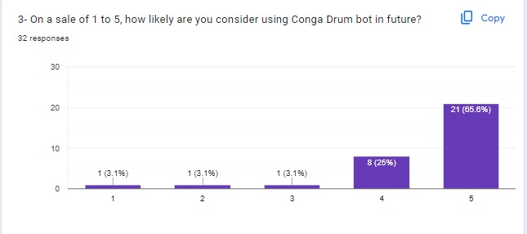
Figure 4.3.3: The Third Online Questionnaire's Results
The bar chart displays the responses to a survey question about the respondents' chances of using the Conga Drum bot in the future. It is evaluated on a scale of 1 to 5, with '1' indicating very unlikely and '5' indicating very likely.
One respondent (3.1%) answered '1', indicating that they are very unlikely to use the bot again.
Similarly, one responder (3.1%) chose '2', indicating that they are unlikely to utilise the bot.
One respondent (3.1%) chose '3' to represent a neutral opinion.
Eight respondents (25%) answered '4', suggesting that they are likely to use the bot.
The majority, 21 respondents (65.6%), chose '5', indicating that they are extremely likely to use the Conga Drum bot in the future.
This indicates that the majority of participants have a high positive attitude towards future use.
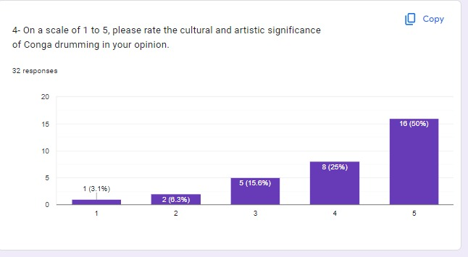
Figure 4.3.4: The Fourth Online Questionnaire's Results
The bar chart depicts responses to a survey question in which participants were asked to rank the cultural and artistic value of Conga drumming on a scale of 1 to 5, with '1' being the least significant and '5' being the most significant.
One responder (3.1%) ranked it as '1', indicating that Conga drumming has minimal cultural and artistic significance to them.
Two respondents (6.3%) rated it as a '2', indicating a low level of significance.
Five respondents (15.6%) answered '3', indicating an indifferent attitude towards its relevance.
Eight respondents (25%) gave it a '4', indicating that they believe Conga drumming is culturally and artistically significant.
The largest group, sixteen respondents (50%), evaluated it as a '5,' indicating that Conga drumming has a very high cultural and artistic significance to them.
This shows that Conga drumming is held in high cultural and artistic regard by the majority of poll participants.
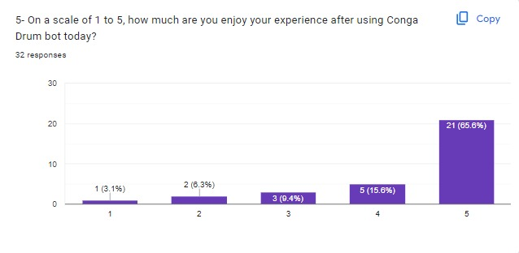
Figure 4.3.5: The Fifth Online Questionnaire's Results
The bar chart depicts the responses to a survey question about the level of enjoyment users had with the Conga Drum bot. Participants were asked to score their enjoyment of the bot on a scale of 1 to 5, with '1' indicating no enjoyment and '5' indicating maximum enjoyment.
One participant (3.1%) evaluated their enjoyment as '1', indicating that they had no enjoyment at all.
Two respondents (6.3%) gave a rating of '2', indicating dissatisfaction.
Three individuals (9.4%) selected '3', suggesting a neutral reaction to their delight.
Five respondents (15.6%) gave their enjoyment a '4', indicating that they were pleased with their experience.
The majority, 21 responders (65.6%), evaluated their enjoyment as a '5', indicating that they had a great time with the Conga Drum bot.
According to the data, a large majority of respondents loved their experience with the Conga Drum bot, with more than half indicating the greatest level of enjoyment.

5.0 Conclusion
Based on the findings of the many surveys and the conceptual framework offered for the CongaDrumBot, the conclusion is that this chatbot is a successful educational and cultural instrument. It has effectively engaged users, increased their enthusiasm for conga drumming, and is associated with the SDGs of Quality Education, Sustainable Cities and Communities, and Decent Work and Economic Prosperity.
The chatbot has helped to spread awareness about the cultural significance of conga drums, encouraging an appreciation for cultural diversity. Its role in fostering economic growth by connecting users with local craftspeople implies that it has a good impact on long-term economic practises. The high levels of satisfaction indicate that users are not only enjoying the CongaDrumBot, but are also likely to use it again in the future, demonstrating its potential for long-term user engagement.
In the future, the CongaDrumBot could incorporate more interactive and personalised features to cater to different learning methods and boost customer happiness. Keeping the information up to speed with the developing cultural contexts of conga drumming and regularly adapting to the latest AI developments for better user interaction are potential challenges. There's also the issue of expanding the bot's capabilities to additional languages and places, improving accessibility, and ensuring that the economic benefits reach a larger community of artists and instructors.
Another possible area for improvement is the use of more comprehensive analytics to better understand user behaviour and preferences, which can then be used to influence targeted updates and enhancements. As the CongaDrumBot interacts with people around the world, scalability and data protection will become more critical, as will cultural sensitivity and relevance across varied user bases.
In conclusion, CongaDrumBot is a promising platform that not only expands users' musical and cultural understanding but also helps to achieve broader socioeconomic goals. It can continue to expand as a successful tool for cultural education and economic empowerment with targeted enhancements and a smart approach to overcome hurdles.

6.0 References
Ta, V. P., Griffith, C., Boatfield, C., Wang, X., Civitello, M., Bader, H., DeCero, E., & Loggarakis, A. (2020). User Experiences of Social Support From Companion Chatbots in Everyday Contexts: Thematic Analysis. Journal of Medical Internet Research, 22(3), e16235–e16235. https://doi.org/10.2196/16235

Bhushan, R., Kulkarni, K., Pandey, V., Rawls, C., Mechtley, B., Jayasuriya, S., & Ziegler, C. (2020). ODO: Design of Multimodal Chatbot for an Experiential Media System. Multimodal Technologies and Interaction, 4(4), 68–68. https://doi.org/10.3390/mti4040068

Vinicios, C., Arthur Azevedo Lima, Henrique, P., Carolina, Matheus, A., Santos, Vieira, S., Aristófanes Corrêa Silva, Daniel, H., Márcia, E., & Eduardo Camacho Fernandes. (2021). A Chatbot Solution for Self-Reading Energy Consumption via Chatting Applications. Journal of Control, Automation and Electrical Systems, 33(1), 229–240. https://doi.org/10.1007/s40313-021-00818-6

Designing Intelligent Personalized Chatbot for Hotel Services | Proceedings of the 2019 2nd International Conference on Algorithms, Computing and Artificial Intelligence. (2019). ACM Other Conferences. https://dl.acm.org/doi/abs/10.1145/3377713.3377791

Muralidhar Madabhushi Balaji, & N. Yuvaraj. (2019). Intelligent Chatbot Model to Enhance the Emotion Detection in social media using Bi-directional Recurrent Neural Network. Journal of Physics, 1362(1), 012039–012039. https://doi.org/10.1088/1742-6596/1362/1/012039

Chakraborty, S., Paul, H., Sayani Ghatak, Saroj Kumar Pandey, Kumar, A., Kamred Udham Singh, & Mohd Asif Shah. (2022). An AI-Based Medical Chatbot Model for Infectious Disease Prediction. IEEE Access, 10, 128469–128483. https://doi.org/10.1109/access.2022.3227208

Maniou, T. A., & Veglis, A. (2020). Employing a Chatbot for News Dissemination during Crisis: Design, Implementation and Evaluation. Future Internet, 12(7), 109–109. https://doi.org/10.3390/fi1207010

Wang, H., Gupta, S., Singhal, A., Poonam Muttreja, Singh, S., Sharma, P., & Piterova, A. (2022). An Artificial Intelligence Chatbot for Young People’s Sexual and Reproductive Health in India (SnehAI): Instrumental Case Study. Journal of Medical Internet Research, 24(1), e29969–e29969. https://doi.org/10.2196/29969

Byeong Jin Ye, Ju Young Kim, Suh, C., Seong Pil Choi, Min Yeong Choi, Dong Hyun Kim, & Byung Chul Son. (2021). Development of a Chatbot Program for Follow-Up Management of Workers’ General Health Examinations in Korea: A Pilot Study. International Journal of Environmental Research and Public Health, 18(4), 2170–2170. https://doi.org/10.3390/ijerph18042170

Hajric, E. (2018). Knowledge Acquisition. Knowledge-Management-Tools.net. https://www.knowledge-management-tools.net/knowledge-acquisition.php

7.0 Workload matrix

No | Task component | Mohammadomar Hashemi  (TP074353) | YEHIA RASHEED YEHIA AL HADDAD  (TP072510) | SULTAN FATEHI ALI HAKAMI  (TP072702)
1 | Problem specification
 | ABSTRACT | 33% | 34% | 33%
 | PROBLEM STATEMENT | 33% | 34% | 33%
2 | Knowledge Acquistion
 | Types of expert system | 34% | 33% | 33%
 | Literature review on chatterbots | 33% | 33% | 34%
3 | Knowledge representation
 | Semantic Nets/Networks | 34% | 33% | 33%
4 | Implementation
 | Jackbot avatar design | 33% | 34% | 33%
 | Jackbot knowledge base implementation | 33% | 33% | 34%
 | Test Plan/screenshots of features | 34% | 33% | 33%
 | User acceptance testing | 33% | 34% | 33%
 | Results of Questionnaire | 33% | 33% | 34%
5 | conclusion
 | Future enhancements | 33% | 34% | 33%

